
LCYU
®
IP68 Defense Touch button 30mm ZMPS30A

seri• es

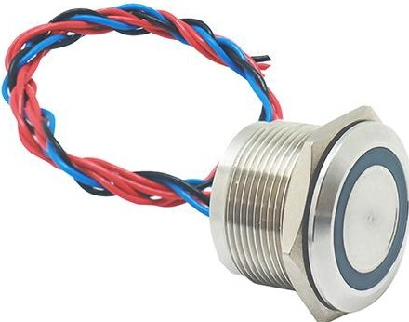

Product Description
Features:
- A variety of styles to choose from:Flat/Chamfer/Concave
- Glued Package IP68 waterproof pure copper wire,good conductivity
. Waterproof,dustproof,flame retardant head waterproof and dustproof flame retardant plastic parts
- LED high light wicks,LED life can reach 30,000 hours bright color,soft bright,long life
- The LED indicators are available in a variety of colors

Product Name | IP68 Waterproof Piezo Switch
Model | ZMPS30A-H1OM |  | ZMPS30A-H10M/D | ZMPS30A-D10M/R
Mounting Hole Size | 30mm
Operation Types | Momentary (Reset)
Switch Combination | 1NO
Actuator Shape | Flat/Chamfer/Concave/High Flat
Terminal type | Wired lead
Illuminated or not | Yes or NO
Led Voltage | 3-24V
Led Color | Blue (Red,Green, Yellow,White,Orange,Purple available)
Illuminated Type | Ring/Dot
Enclosure Material | Stainless Steel/ Aluminum
Rated Current | 2A
Contact Resistance | 50 mn max
Operating Force | 6 to 15N
Dielectric Intensity | 2000VAC
Operating Temperature | -40°C to +75°C
Accessories | Nut, Rubber Waterproof O-ring
Customized symbol,colored housing or Connector |  | Acceptable and with fast shipping
Choose 2/3 colors from two-color/three-color light combination (above colors)
Note: Dot lights are only available in the first 5 colors
Product Parameter

<1>33.00 (1.299DIA)
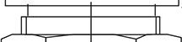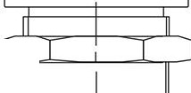E;:::I ::t===t
I
..........., , ----=--,.....-, oco
(') .
-
:::
,t
<1>28.50
(1.122D!A)
<D30.00 x 1.00 SII
_
(1.181DIAx1.001S
)
...
<1>33.00 (1.299D!A)
<1>27.00 (1.063D!A)

i ----+----=-. , 0:
;:-1

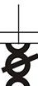cr>.f.'.-.;.,

<1>28.50 (1.122D!A)
000
LO (I') ,.............. --'----, o,-...
- U'),....
,q·--.._;,

, --=--.,........... -

0 -
0,-...
C\1--0
<1>35.00 (1.3780IA)

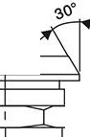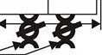<1>33.00
3.50
(.138)
<I>30.00x 1.00SI -> ,0.
(1.1810IAx 1.00IS)
AWG26
30CM
►
(1.2990IA)4

i ._---+----=-........ , o-
ZMPS30A-H1OM
<1>33.00
(1.2990IA)
,.
►
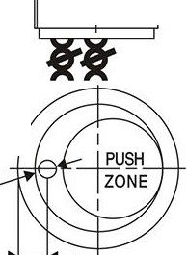1
o
O- )t.-., ,
II) :g
----'-------=:;..............
-
.... ----.------=,,..........
00)
0. -
(')
·-
0
DIA)

.50
256)

<1>27.00
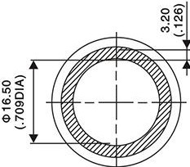
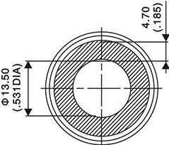
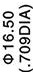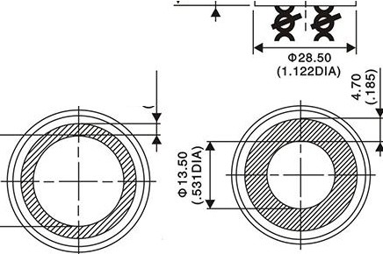 (1.0630IA)
O<D
C\I C\I
('
·-
) .

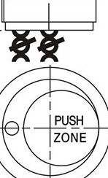- ....:, ,,
.---'------'='-....,. ,

IED
<!>3.0
(.118

...;.

<!>30.00 x 1.00SI -C of.
{1181D1Ax1.00IS)@iil.;J I
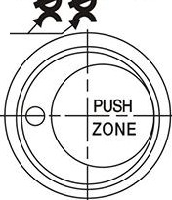
AWG26
30CM

ZMPS30A-D1OM/R

6
{.

ZMPS30A-H1OM/D

