(@®
$3=ij::;

Model Description for Piezo switch
For example:NK16A-PNOF-EB12V/As
* ■ □ ... 6 ♦ ◊
ff  plezo switch  code | JLR-t  Mounting hole size | Type | fl *llx  Head shape | H;t:ffi: Switch combination | t,\H'l=: rn Operation types | *!l:T Lamp types | !1:TTSl<Wi !Mi'M  LED color  /Button color | !l:TT* ff  LED voltage | 91'  Housing
 | 12 <t:>12mm | A | p | NO | F:Momentan | Blank | Blanlc Non-ibum. B: Blue  G: Green Y: Yellow R:Red W:white  RG: Red/Green RY: Red/Yellow RB: Red/Blue RW: Red/White GB: Green/Blue GY: Green/Yellow GW: Green/White BY: Blue/Yellow YW: Yellow/White RGB: R/G/B RGY: R/G/Y RGW:R/G/W RBY: R/B/Y RBW:R/B/W RYW: R/Y/W GBY: G/B/Y GBW:G/B/W GYW:G/Y/W  BYW: B/Y/W | SV(DC) | As
 | 16 <!J16mm | B | P1 | NC | (2 wire leads | E |  | 12V(DC) | Ab
 | 19 <!J19mm | C | P2 | K (proto- |  | EO |  | 24V(DC) | Aa
 | 22 <t:>22mm  25 <!J25mm  28 <!J28mm  30 <!J30mm | D E  ......
 | 22 <t:>22mm  25 <!J25mm  28 <!J28mm  30 <!J30mm | D E  ...... | PY |  |  |  |  |  | s
 |  |  | PZ

i1: iwfHIHmlw:.1" .F wi1H1*, -. :flUJ.s liil.F ttJ x tE**q:iii£ijW:Im1-\::-&o
Note: Please read carefully product detailed information,according to different product structure state in the table select the corresponding code.
* Head Shape:
P =Flat, operator heighe 12mm=1.5, 16/19/22/25/30mm=1.30(non-illum)
P1 =Flat, operator height 4.50(16mm only)
P2 =Flat, operator height 3.00(not available with ring illum.)
PS =Operator with finger location, height 12mm=1.5, 16mm=4.50(non-illum.) P6 =Finger location, operator height 3.00(not available with ring ilium.)
PA =Chamfer, operator height 3.00(19mm only)
PY =Chamfer, operator height 4.S0(available with thin or large ring ilium only) PZ =Flat, operator height 4.S0(available with thin or large ring illum only)
The operator can be customized

.A. Operation types: Blank =Non-ilium
E =Ring for operater 13.5 EO =Ring for operater 16.5 D =Dot

l*w 1:mooSurface Effect \

Notice:
- Housing:
As =Natural anodized Ab =Blue anodized Aa =Black anodized Ag =Green anodized Ay =Gold anodized Ar =Red anodized
S =Stainless steel 316L

  - The latching functions is with 3 or 4 wire leads
  - 12mm switch is with NO only,NOT for 3 wire leads
  - Standard Accessories supplied: 1 hex and 1 O-ring
  - Custom marking available
  - Ratings: 200mA 24VAC/DC
(1A 24VAC/DC is available) For options not listed,please contact us.

$ Efi=i

Bushing/operator All models with <D 12 bushing

Flat

Finger location
P5 Operator with finger location. Blank Flat operator, height 1,20(.047)

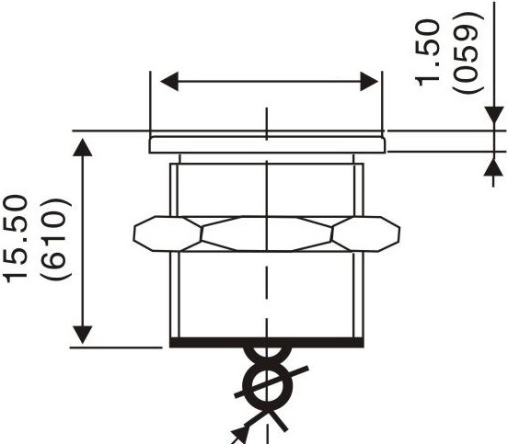12A-PNOF
(1)17.00
(669 DIA)
AWG24 30CM

$12.20
(480 DIA)
((1) .472 X 1.0)/-""l!'l'!,. llllil

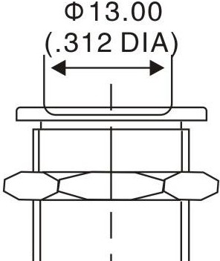
P5
(1) 12 X 1.0

Bushing/operator All models with <D 16 bushing

16A-P1NOF

<I> 18.00 o

Flat

Finger location
P1 Flat operator, height 4,50(.177) p5 Operator with finger location.
height 4,50(.177)(non-illuminated)

Blank Flat operator, height 1,30(.051)

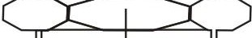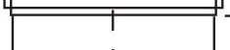<I> 13.00
<I> 18.00
(.708 DIA)
=-
o l
l!) r---
t
I
•

(.708 DIA)

o o
. l!)
"<l" l!)
.._;,,

AWG26 30CM

C') l!)
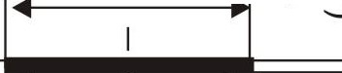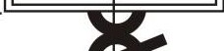,....:

o
o.r-c-o-
or---
C\J .._;,,

oOr-l--J

LO:_

<I> 16.00 x 1.00 SI
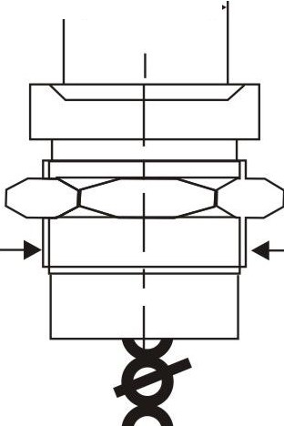 (.630DIA x 1.00 IS)
(...512DIA)

P1 P5

$3=Efi=i

Bushing/operator

All models with <D 16 bushing

Flat operator, height 1,30(.051)

Flat

16A-PNOF-D

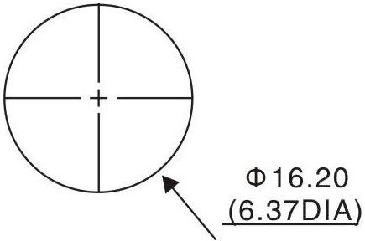 A,,W,, ;,6 ,,'f .-.

t <D 16.00 x 1.00 SI (.630DIA x 1.00 IS)
IED
<D3.00 (.11SDIA)

3.70
(.146)

Bushing/operator

All models with <D 16 bushing

Flat operator, height 4,50(.177)

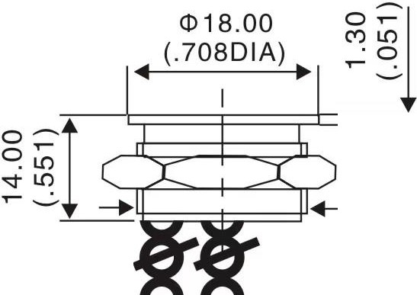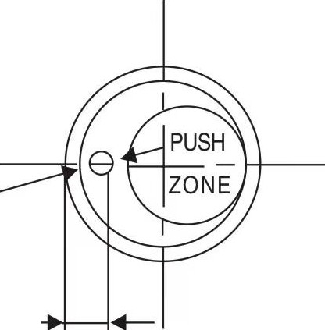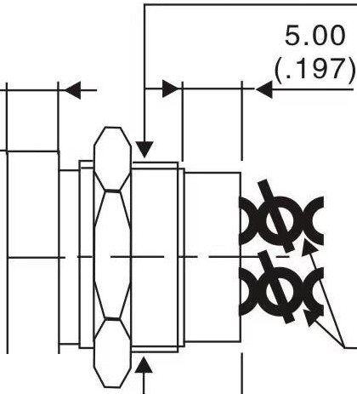16A-PNOF-E

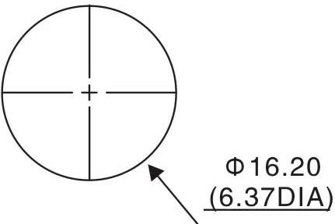

4.50
(.177)
e�or!--:1--

<ll 16.00 x 1.00 SI (.630DIA x 1.00 IS)

AWG26 30CM

20.00
(.787)

(!)13.50
(.531DIA)

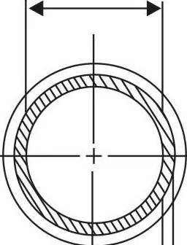

1.20
(.047)

Cw®

$3=Efi=i

Bushing/operator

Flat
All models with CD 19 bushing

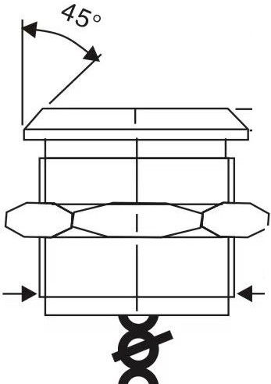19A-P2NOF
oa,
or--­
C\J·o .
CD 19.00 x 1.00 SI (.748DIA x 1.00 IS)

Chamfer

P2 PA

Blank
Flat operator, height 3,00(.118)

Operator with chamfer, height 3,00(.118)
Flat operator, height 1,30(.051)

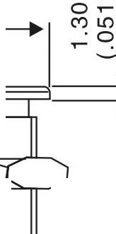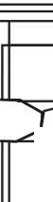aCX)
r---
._;,, .,,..£--=--' =-..:,,..,,._/'
t
CD22.00 (.886DIA)

'+------.-.-+--,-, I'

or---
- CX)
0 1
or--­
C\J._;,,
CD22.00 (.886DIA)

AWG26 30CM
AWG26 30CM

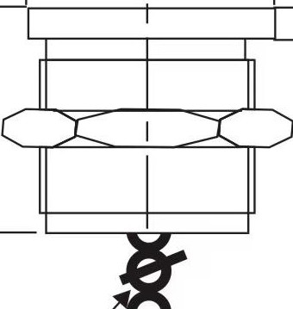
P2 PA

Bushing/operator

Flat

All models with CD 19 bushing

Flat operator, height 1,30(.051)

19A-P2NOF-D

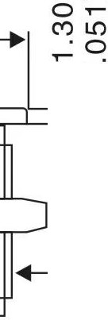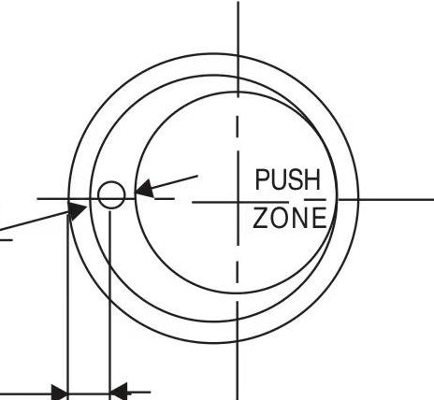CD22.00 (.866DIA)

Ct> 16.00 x 1.00 SI
(.630DIA x 1.00 IS)
IED CD 3.00
(.11BDIA)
6.50
(.256)

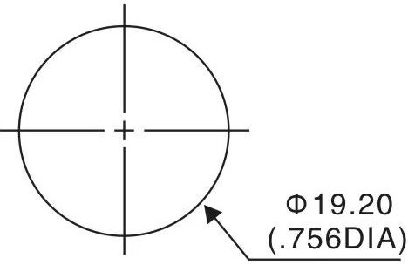
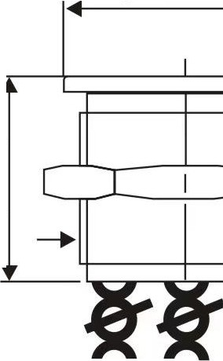o
�
X) r--.
.o(j)
._;,
0
C

A W,. -6

.,

Cw®

$3=Efi=i

Bushing/operator

All models with CD 19 bushing

Flat P2

PA
Chamfer
Flat operator, height 3,00(.118) Operator with chamfer,
height 3,00(.118)

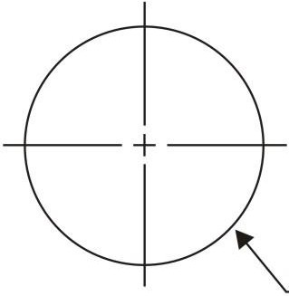
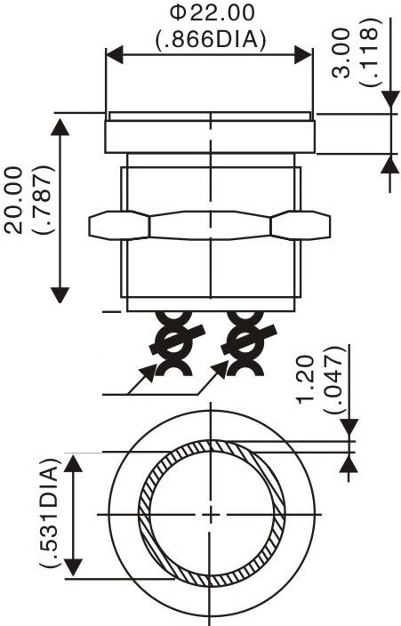19A-PANOF-E
AWG26 30CM

(1)19.20
(.756DIA)

P2

or--­
N.._;,
·o
om

---... -,--...,,. Cll 19.00 x 1.00 SI
(.748DIA x 1.00 IS)

PA

Bushing/operator All models with CD22 bushing

Flat
P2 Flat operator, height 3,00(.118)(non-illum.)
P6 Finger location,operator height 3,00(.118)(non-illum.) Blank Flat actuator, height 1,30(.051)

Finger location

22A-P2NOF

(1)25.00
(.984DIA)

(!)20.50
(.807DIA)
(!)28.00 (1.102DIA)
(!)22.00
(.866DIA)

<D 22.00 x 1.00 SI (.866DIA x 1.00 IS)

(!)20.50
(.807DIA)

AWG26
30CM

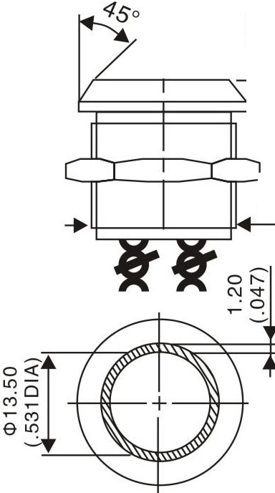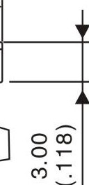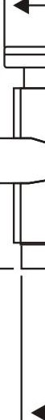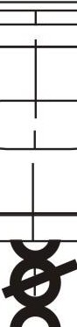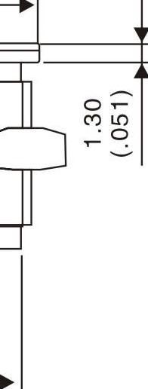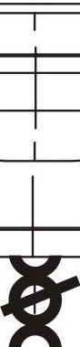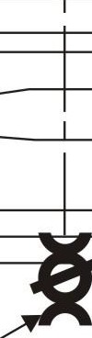
P2 P6

Cw®

$3=Efi=i

Bushing/operator

Flat
All models with <D22 bushing
P2 Flat operator, height 3,00(.118)(non-illum.)
P6 Finger location,operator height 3,00(.118)(non-illum.) Blank Flat operator, height 1,30(.051)

Finger location

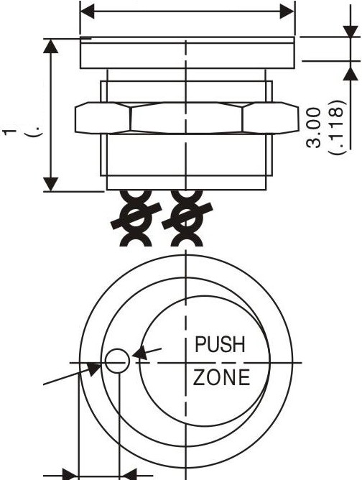<ll28.00 (1.102DIA)

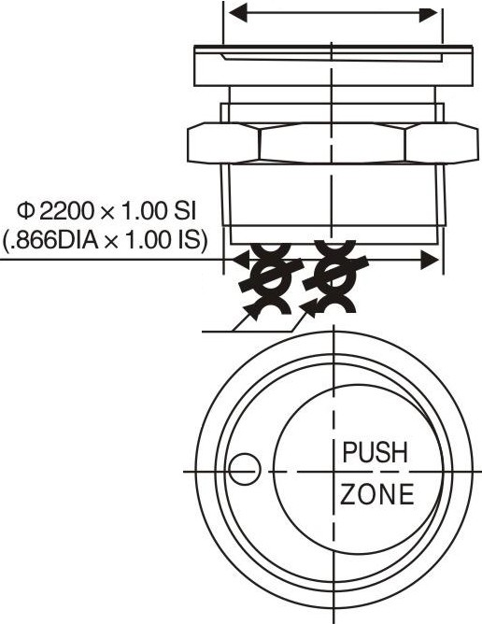<ll22.00 (.866DIA)
AWG26 30CM

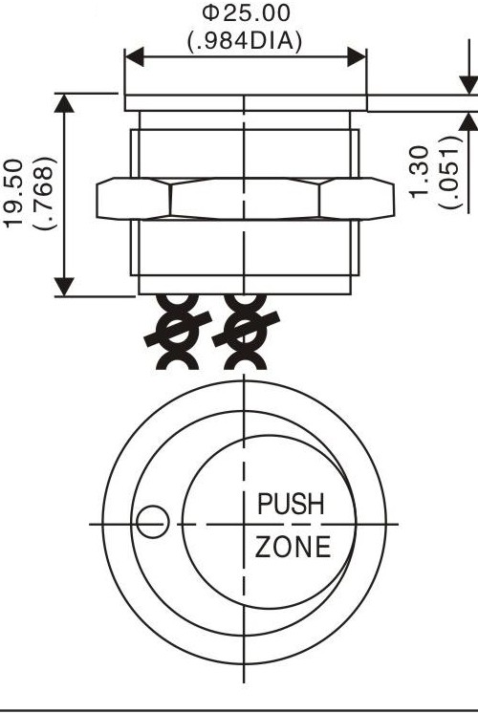o­
22A-P2NOF-D
"' .wtO
0) ,

IED
<ll3.00 (.118DIA)

6.50
(.256)

Flat Chamfer

P2 P6

Bushing/operator All models with <D22 bushing
PY With chamfer, operator height 4,5mm (.177).
or large illuminated ring only
PZ Flat operator, height 4,5mm (.177). or large illuminated ring only

22A-PYNOF-E
<Jl28.00 (1.102DIA)

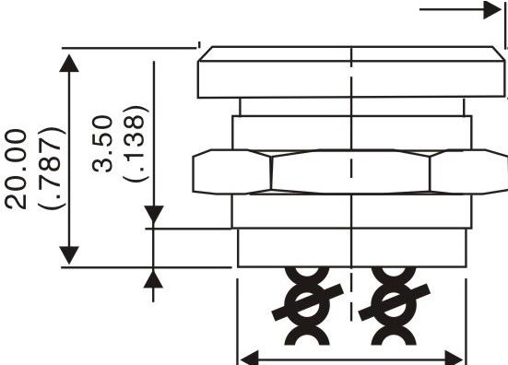<Jl20.50 (.807DIA)
2.00
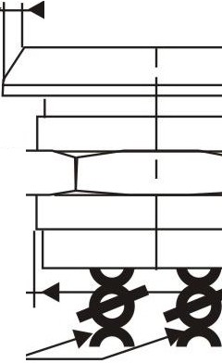(.079)

<l> 22.00 x 1.00 SI (.866DIA x 1.00 IS)
AWG26
30CM

,Jf
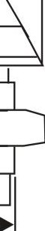

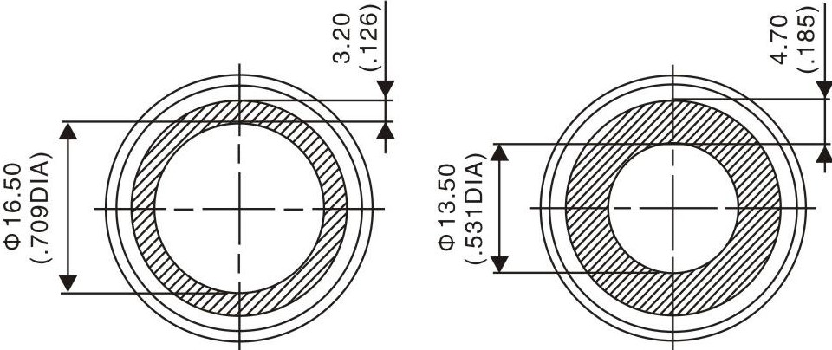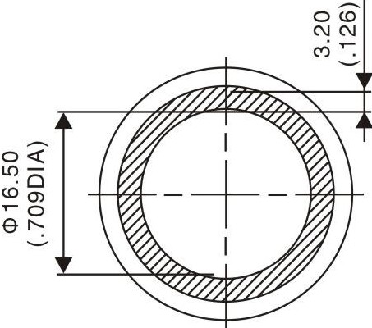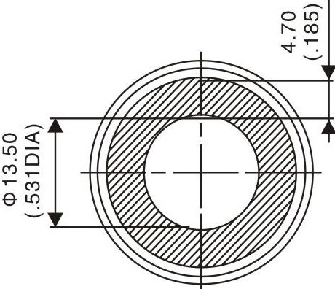

PZ PY

$§:ij=i

Bushing/operator

All models with <D25 bushing

P2 Flat operator, height 3,00(.118)(non-illum.)
P6 Finger location.operator height 3,00(.118)(non-illum.) Flat Blank Flat operator, height 1,30(.051)
Finger location

25A-P2NOF

<ll28.00 <ll22.00
<ll28.00 (1.1020IA) (.866DIA)
(1.1020IA) =1
o j
OB
0
C') U'.)

U'.) tO
. <O
Ol r--
-..:-
<ll23.50
◄ (.925DIA} ►

<ll23.50 (.925DIA)

P2
ºM�:=,

<ll 25.00 x 1.00 SI (.984DIA x 1.00 IS)
I

M

P6

Bushing/operator

All models with <D25 bushing

P2 Flat operator, height 3,00(.118)(non-illum.)
P6 Finger location,operator height 3,00(.118)(non-illum.) Flat Blank Flat operator, height 1,30(.051)
Finger location

205A-P2-NOFr-D - 0;:-

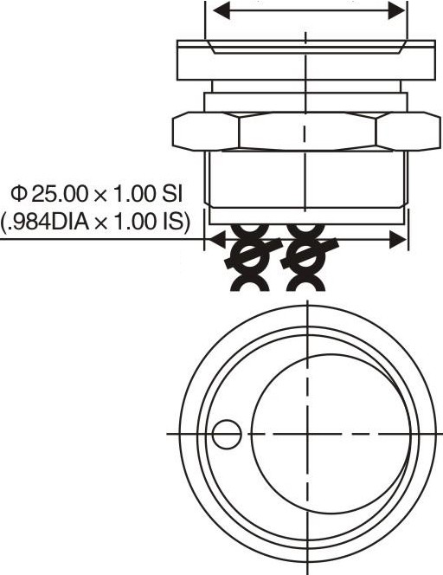<ll28.00 (.984DIA)
AWG26 30CM
<ll28.00 (1.102DIA)
<ll22.00 (.866D!A)

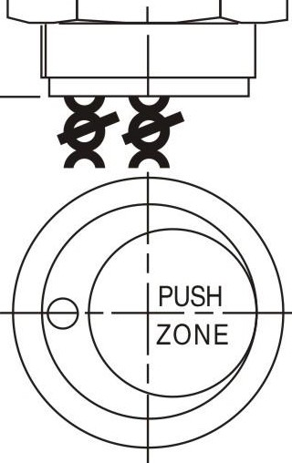
"-'-, _.:,

......,_..-1----.

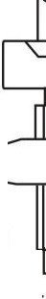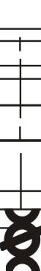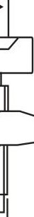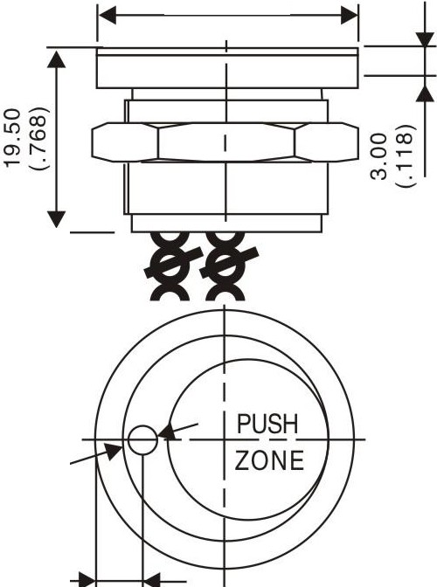

IED
<ll3.00 (.118DIA)

6.50
(.256)

P2 P6

$3=Efi=i

Bushing/operator

Flat Chamfer
All models with <D25 bushing
py With chamfer.operator height4,5mm(.177) or large illuminated ring only
pz Flat operator, height 4,5mm(.177) or large illuminated ring only
Blank Flat actuator.height 1,30(.051)

25A-PYNOF-E

<1>30.00 (1.1810IA)

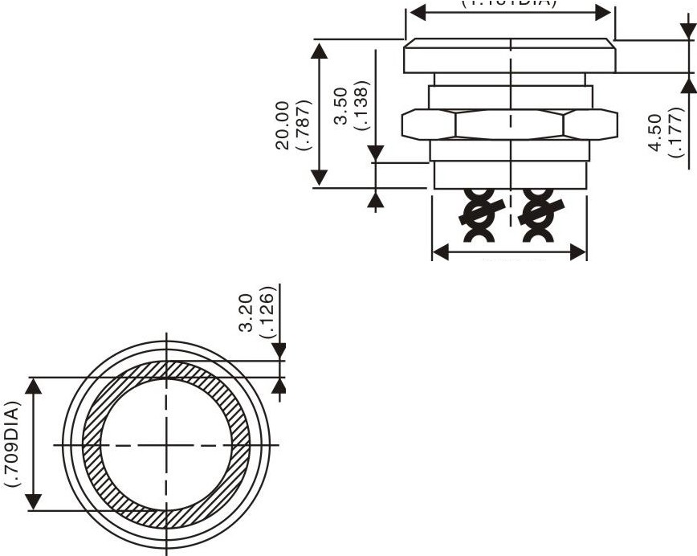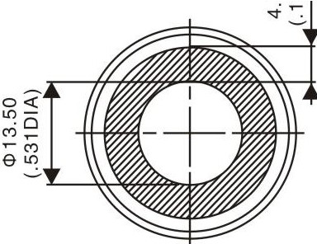<1>23.50 (.925DIA)

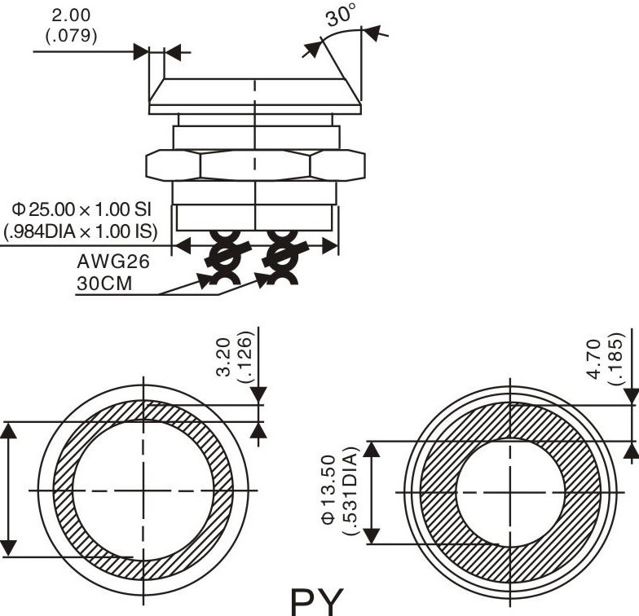
;;,
0
r--<Xl

;,-
0
0"'
'.:
PZ

Bushing/operator All models with <D30 bushing
P2 Flat operator, height 3,00mm(.118)(non-illum.)
P6 Flat location,operator, height 3,00mm(.118)(non-illum.) Flat Blank Flat actuator.height 1,30(.051)
Chamfer

30A-P2NOF

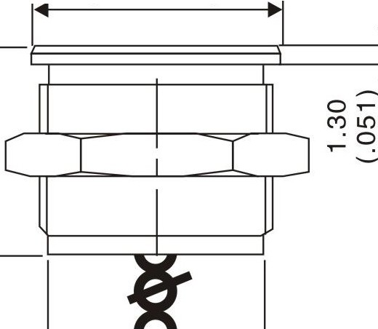<D33.00 (1.2990IA)
<D33.00 (1.2990IA)

<D27.00 (1.0630IA)

.'(°0
,0.)... r--­
_;.

oo,c-o
M

<D 30.00 x 1.00 SI (1.181DIA x 1.00 IS)I ... ,,_.,. .

<D28.50 (1.1220IA)
<D28.50 (1.1220IA)

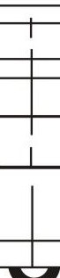
P2 P6

$3=ij:;

Bushing/operator All models with <l>30 bushing

Flat
Finger location
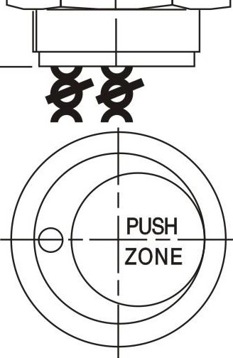
0-1- g
►
30A-P2NOF-D
$33.00
.. (1.2990IA)
ci ,............,,,..--;-=---'--.., ...:
..:-
P2 Flat operator, height 3,00(.11S)(non-illum.)
P6 Finger location.operator height 3,00(.11S)(non-illum.) Blank Flat operator, height 1,30(.051)
$33.00 (1.2990IA)
$27.00 (1.0630IA)

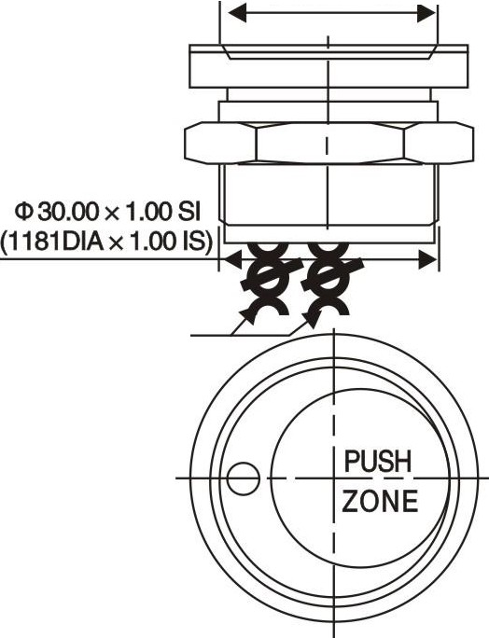IED
AWG26 30CM
$3.00 (.118DIA)

6.50
(.256)

P2 P6

Bushing/operator All models with <l>30 bushing

Flat Chamfer
py With chamfer, operator, height 4,Smm(.177). or large illuminated ring only
PZ Flat.operator height 4,Smm(.177). or large illuminated ring only

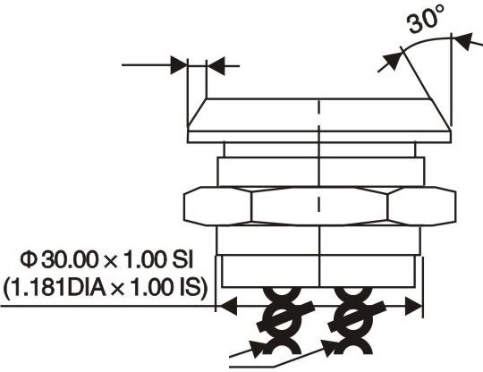30A-P2NOF-E $35.00 (1.3780IA)
3.50
(.138)
AWG26
30CM

fII I f
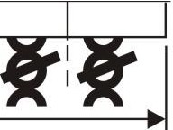
Nv <

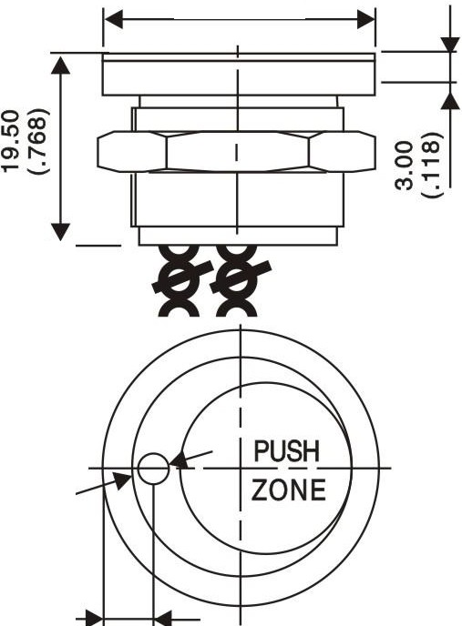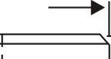

O<D
MNN:,_
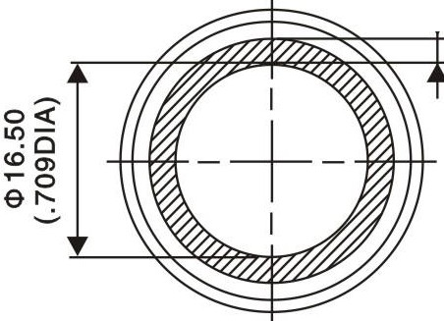PZ
I ..

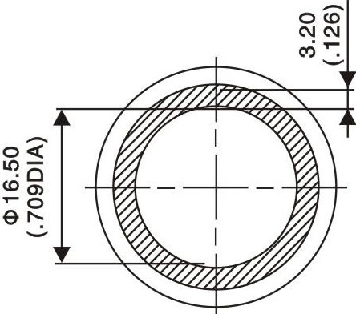
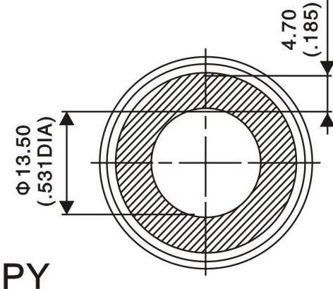
$28.50 (1.1220IA) 0 io
:.
I'- co
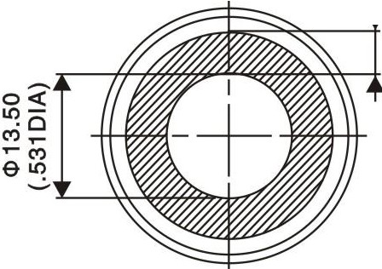
...,:

$3=Efi=i

FINGER PRESSURE
[ '! ·14 t> 201
I I
applied to switch

1 = pressure
0 = no pressure

OUTPUT

- Momentary NO (pulse)
No external power supply required

- Momentary NO (pulse)
No external power supply required

- Momentary NO prolongated pulse
No external power supply required

- Latching (ON-OFF)
Requires external power supply

Wiring diagrams
BRED
RED

Momentary NO

Non-illuminated
1 = closed output O = opeb output

1 LED *

3 LEDs
RED
...
Ll-
2 LEDs

"'
RED

I
I
A B A B
[t]="R'ED

A BA BAB

-
E)'"
RED

I
RED
'"
A B

RED
RED

Momentary NC

"' RED
A B

A B A B
.R.ED

RED

RED

Momenta NO
prolongate pulse

"'
I

RED
I

A BA BA B
E)"

-

I
R'ED

A B

- ^{_1} I BLACK
BLUE
l§e: :

Larching (ON • OFF)
v> -
L-J BLACK
BLUE
I;
-=+-
I;
-=-++
A B A B
IL-=>+//- -
V
A BA BA B

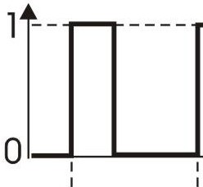
I I I
:r-u-----u--------------n ---- --
---- -
:□I
- t
I
:
□:I
I
:
/I 1
1
]--- I
I

.-
- t
Up to 20s ---+
1--------
i 0 :,
:I
---1
:j
- t
: 1......... I-----L-.----1---------------L I .
- t

Legend:B = black, A= same colour as LED
BLACK BLACK

BLUE
*LED colour is indicated by the bottom of the product.

